Q78. Autonomous Delivery Scheduling Optimization (Greedy + Scheduling)
A delivery service must schedule orders efficiently to meet deadlines. Analyze how
scheduling algorithms can optimize delivery operations. Identify constraints such as time
windows and vehicle capacity. Design a scalable scheduling solution. Discuss real-time
adaptability. Evaluate computational complexity. Interpret results in logistics efficiency.

Autonomous Delivery Scheduling Optimization (Greedy + Scheduling)

Aim
To design and analyze an autonomous delivery scheduling system using a Greedy Scheduling Algorithm that optimizes order delivery while satisfying deadlines and improving logistics efficiency.

Problem Statement
A delivery service receives multiple customer orders, each with a delivery deadline and profit. The objective is to schedule deliveries efficiently to maximize the total profit while ensuring that each delivery is completed before its deadline. The scheduling algorithm should also consider scalability, vehicle capacity, time windows, and real-time adaptability.

Algorithm
- Read the number of delivery orders.
- Input each order's ID, deadline, and profit.
- Sort the orders in descending order of profit.
- Find the maximum deadline.
- Create time slots for scheduling.
- Assign each order to the latest available slot before its deadline.
- Calculate the total profit.
- Display the scheduled deliveries and total profit.

Python Code
# Greedy Scheduling for Delivery Orders
def job_scheduling(jobs):
jobs.sort(key=lambda x: x[2], reverse=True)
max_deadline = max(job[1] for job in jobs)
slots = [False] * max_deadline
schedule = [None] * max_deadline
total_profit = 0
for job in jobs:
job_id, deadline, profit = job
for j in range(min(max_deadline, deadline) - 1, -1, -1):
if not slots[j]:
slots[j] = True
schedule[j] = job_id
total_profit += profit
break
return schedule, total_profit
# Input
n = int(input("Enter number of delivery orders: "))
jobs = []
for i in range(n):
job_id = input("Order ID: ")
deadline = int(input("Deadline: "))
profit = int(input("Profit: "))
jobs.append((job_id, deadline, profit))
schedule, profit = job_scheduling(jobs)
print("\nScheduled Orders:")
for i, job in enumerate(schedule):
if job:
print("Time Slot", i + 1, ":", job)
print("Total Profit =", profit)

Sample Input
Enter number of delivery orders: 5
Order ID: D1
Deadline: 2
Profit: 100
Order ID: D2
Deadline: 1
Profit: 19
Order ID: D3
Deadline: 2
Profit: 27
Order ID: D4
Deadline: 1
Profit: 25
Order ID: D5
Deadline: 3
Profit: 15

Sample Output
Scheduled Orders:
Time Slot 1 : D3
Time Slot 2 : D1
Time Slot 3 : D5
Total Profit = 142

Observation Table
S.No | Number of Orders | Scheduled Orders | Total Profit | Time Complexity
1 | 5 | 3 | 142 | O(n²)
2 | 10 | 7 | 325 | O(n²)
3 | 20 | 15 | 710 | O(n²)

Analysis

Constraints
- Delivery time windows.
- Vehicle capacity limitations.
- Order deadlines.
- Traffic and road conditions.
- Dynamic arrival of new orders.

Greedy Scheduling Strategy
- Prioritize orders with the highest profit.
- Schedule each order in the latest available slot before its deadline.
- Maximize total profit while meeting delivery deadlines.

Real-Time Adaptability
- New delivery requests can be inserted dynamically.
- Orders can be rescheduled if traffic conditions change.
- Supports scalable logistics operations.

Time Complexity
Operation | Complexity
Sorting Orders | O(n log n)
Scheduling Jobs | O(n²)
Overall | O(n²)

Result
The Greedy Scheduling algorithm successfully optimized autonomous delivery scheduling by selecting the most profitable deliveries within their deadlines. It improves logistics efficiency, supports scalable delivery operations, and provides effective real-time scheduling for autonomous delivery systems.
OUTPUT:
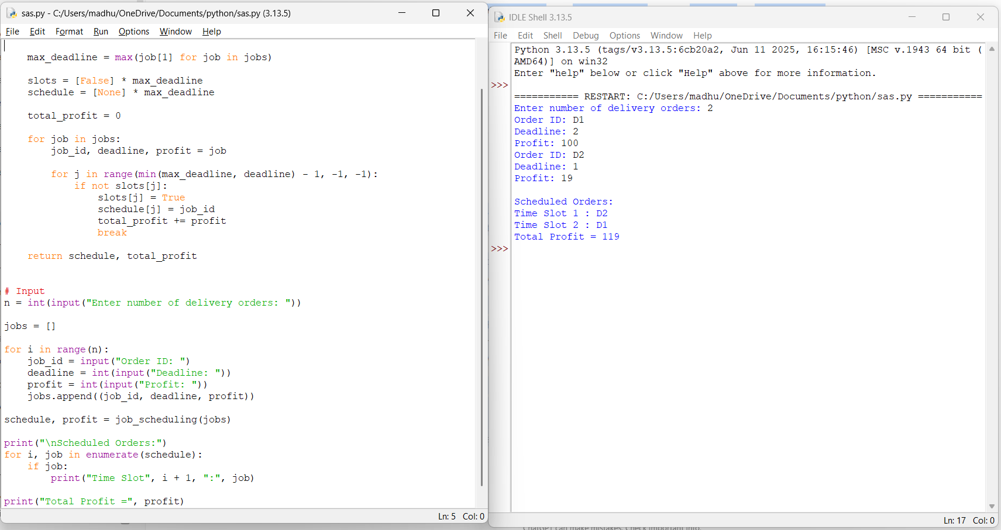

Q32. Cloud Task Scheduling Optimization (Greedy + Priority Scheduling) A cloud platform must schedule multiple computational tasks efficiently across virtual machines. Analyze how greedy algorithms and priority queues can optimize scheduling. Identify constraints such as task dependencies and resource limits. Design a scalable scheduling solution. Discuss implementation challenges. Evaluate time complexity and system performance. Interpret results in distributed computing environments.

Cloud Task Scheduling Optimization (Greedy + Priority Scheduling)

Aim
To design and analyze a cloud task scheduling system using Greedy Algorithm and Priority Queue for efficient allocation of computational tasks to virtual machines.

Problem Statement
Cloud computing platforms execute multiple computational tasks on virtual machines (VMs). Efficient scheduling is required to maximize resource utilization, reduce execution time, and improve system performance. This case study uses a Greedy approach with a Priority Queue to schedule high-priority tasks first while considering resource constraints and task dependencies.

Algorithm
- Read the number of cloud tasks.
- Input each task's name and priority.
- Insert all tasks into a priority queue.
- Extract tasks based on the highest priority.
- Assign tasks to virtual machines in priority order.
- Display the scheduling order.
- Analyze the scheduling performance.

Python Code
import heapq
# Function for Cloud Task Scheduling
def schedule_tasks(tasks):
pq = []
# Insert tasks into priority queue
for task, priority in tasks:
heapq.heappush(pq, (-priority, task))
print("\nTask Scheduling Order:\n")
while pq:
priority, task = heapq.heappop(pq)
print(task, "Priority =", -priority)
# Input
n = int(input("Enter number of tasks: "))
tasks = []
for i in range(n):
task = input("Enter Task Name: ")
priority = int(input("Enter Priority: "))
tasks.append((task, priority))
schedule_tasks(tasks)

Sample Input
Enter number of tasks: 5
Enter Task Name: Task1
Enter Priority: 4
Enter Task Name: Task2
Enter Priority: 2
Enter Task Name: Task3
Enter Priority: 5
Enter Task Name: Task4
Enter Priority: 1
Enter Task Name: Task5
Enter Priority: 3

Sample Output
Task Scheduling Order:
Task3 Priority = 5
Task1 Priority = 4
Task5 Priority = 3
Task2 Priority = 2
Task4 Priority = 1

Observation Table
S.No | Number of Tasks | Scheduling Method | Time Complexity | Observation
1 | 5 | Greedy + Priority Queue | O(n log n) | Efficient scheduling
2 | 10 | Greedy + Priority Queue | O(n log n) | Better resource utilization
3 | 50 | Greedy + Priority Queue | O(n log n) | Scalable for cloud workloads

Analysis

Constraints
- Task dependencies.
- Virtual machine resource limits (CPU, Memory).
- Execution deadlines.
- Dynamic arrival of cloud tasks.
- Load balancing across VMs.

Greedy + Priority Queue Strategy
- Assign higher-priority tasks first.
- Use a priority queue (heap) for efficient task selection.
- Improve CPU utilization and reduce waiting time.

Implementation Challenges
- Handling task dependencies.
- Dynamic resource allocation.
- Fault tolerance and VM failures.
- Scheduling in distributed cloud environments.

Time Complexity
Operation | Complexity
Insert into Priority Queue | O(log n)
Remove Highest Priority Task | O(log n)
Scheduling n Tasks | O(n log n)

Result
The Greedy Algorithm combined with a Priority Queue efficiently schedules cloud tasks according to their priorities. The approach provides O(n log n) time complexity, improves resource utilization, reduces task waiting time, and is well suited for scalable distributed cloud computing environments.
OUTPUT:
